Hi EHT,

Hope everything is going well on your side!

First, Shep and Scott, thank you for answering our questions in the previous email. It has been our pleasure working with all of you at the EHT and we look forward to having our next meeting very soon. In this email, we want to update you on our current stage and share our plans for the near future. Please see below for a short progress report. Please let us know if you have any suggestions or concerns regarding our project and we will look forward to keeping in contact with you along the term.

We have also attached our latest Scope of Work document. It states our understanding of the problem statement, expectations on the final deliverable and the expected timeline. Please make sure those are aligned with yours.

Sincerely,

Queena, Shu, and Yiming

**Current stage:**

Data Problem

We have successfully pulled data for the past two weeks and will continue to pull the data. With these data, we were able to conduct exploratory data analysis. The results include line graphs and estimated variances of the forecast, which we plan to show you next week. One of the plots is shown below. As you can see, there might be some errors associated with our data: we noticed a surprising number of zeros and huge values of tau-225 (the spikes in the plot), which did not exist in the small sample dataset that Scott sent to us a while ago. Hope we can discuss this during our next meeting.

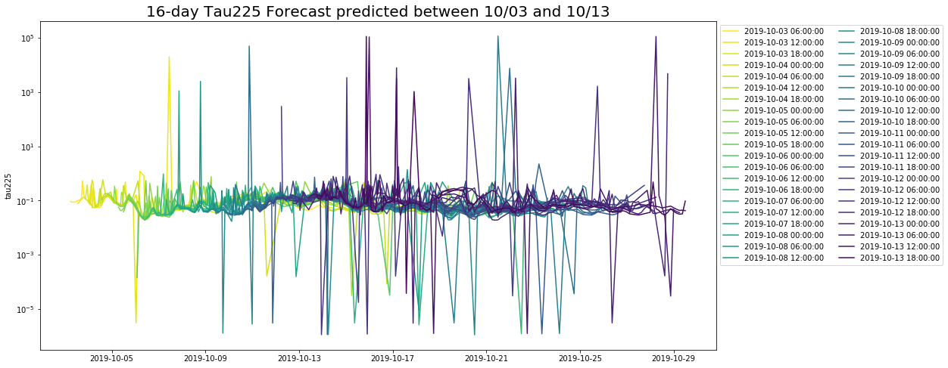

Base Model

We have built a baseline model, which we can explain more to you during our next meeting. The basic idea is that we use the negative tau225 as the reward for one single telescope and calculate the weighted-sum of them for all telescopes. Then we perform some simple optimization to get the scheduling results. We tested our baseline model on the 10-day window from Oct.5 to Oct.14, and got the results as follows. You can see the comparison between our model’s output and the best path we can take from looking back.

|  |  |
| --- | --- |
| Path suggested by Baseline | Ground-truth Best Path Afterwards |
|  |  |

**Our plan for the next few weeks:**

We are going to continue exploring different kinds of reward functions and build up our model. Something we have in mind was to take the log at the tau225 values, so the outliers become less extreme. We are also going to experiment with discount factors, which can give less weight to the reward on the days further out. Using the discount factors technique will also make it possible to adjust the strategy focus between good weather and number of days left. We are still brainstorming how we could apply the variances in the forecast data to produce the confidence level. In the meanwhile, we can also start using more indicators like water vapor and ozone to build the reward function.